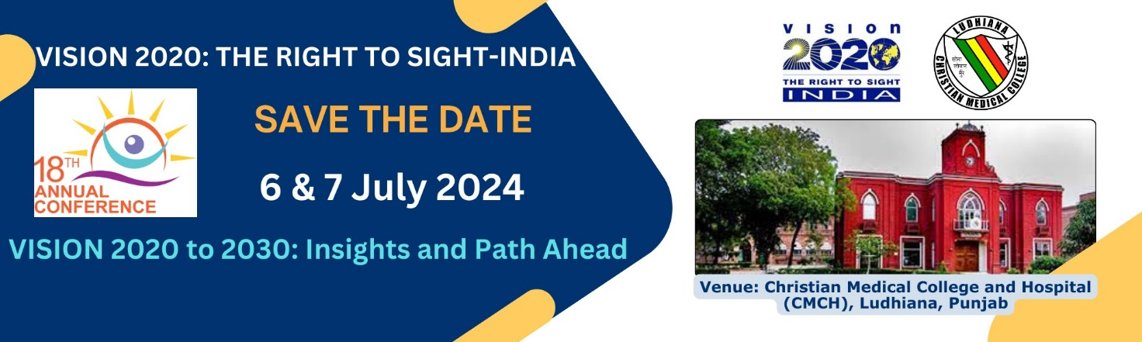
Scholarship Guidelines - 2024

Objectives:
- Provide an opportunity to the students of Optometry and help them develop & maintain relevant skills of optometry practice.
Who is eligible?
- Students of optometry studying/doing their internship. These students must be studying the optometry at any of the Optometry colleges run by the member hospitals/institutions of VISION 2020 India.
What does Scholarship cover?
- One scholarship value is upto Rs.10,000 (Rupees Ten Thousand only) for travel and accommodation together. This is a maximum amount that can be offered for each scholarship.
- To & fro travel to Ludhiana, Punjab (either by train or flight, including local travel expenses).
- Accommodation costs during conference period for two nights.
- After successful participation, each applicant will receive a Certificate of Scholarship.
Other Important Points:
- Applicant must participate in the annual conference at Ludhiana for both the days.
- All participants must register online: http://www.vision2020indiaannualconference.org/ Kindly note that without paying registration fee, the scholarship offer remains invalid.
- Only one scholarship is permitted per member hospital, on first-cum-first serve basis.
- Applicants from long-distance will be given preference.

How to receive Scholarship amount?
You need to incur expenditure and retain all original bills. VISION 2020 INDIA will reimburse the applicable amount.
After the completion of conference and you are back to your location, you are required to do the following:
- Send the original bills supporting your claim of travel and stay. Please ensure that such bills are made in your name/your hospital/your institution name.
- Submission of original bills is mandatory.
- Note that the amount of reimbursement will be either upto Rs.10,000 or the amount as per bills submitted, whichever is lower.
Case 1 - your total value of bills (for both outstation/local travel and stay) is Rs.10,200, the amount of reimbursement will be only Rs.10,000/-
Case 2 – your total value of bills (for both outstation/local and stay) is Rs.9750, the amount of reimbursement will be only Rs.9750/-

- Reimbursement will be made either by cheque or by NEFT/RTGS mode in the name of applicant/applicant institution, as per account details provided in the scholarship application form.
Claim Details be sent to:

Sub: Scholarship Application Documents

To
Program Manager
VISION 2020: The Right to Sight – INDIA
Building No. 36, Flat no. 105, 1st Floor
DDA Community Center, Zamrudpur
Kailash Colony, New Delhi- 110048
Office: +91 966 707 88 66
Contact:
For any queries on scholarship, please call / write to:
Dr Kalpana Yadav, Program Manager, VISION 2020: The Right to Sight-INDIA
Mobile: 983 156 47 99, Email: program@vision2020india.org

****

